To: David Garshelis

From: John Fieberg

Date: 25, September 2015

RE: Progress report: Genetic-based estimates of bear populations: maximizing bang for the buck

**Purpose**

The purpose of this report is to summarize my activities and progress for the time period: 1 July 2015 – 30 September 2015, during which I charged roughly 3 weeks of summer salary to this account.

**Summary**

My efforts during this time period were devoted to: 1) working with David Garshelis to gather and clean data from the spatial-mark-recapture study; 2) writing code to obtain preliminary estimates of the density of black bears in the CNF study area using a variety of spatial mark-recapture models fit using the secr package in Program R (Efford 2015, R Core Team 2014); 3) writing code to estimate the number of black bears in the superpopulation of bears “at risk” of being captured at the set of hair snare traps in the CNF study area using (non-spatial) mark-recapture models that allow for individual covariates (i.e., the “Huggins” model in Program MARK). In the latter case, I used Program R (R Core Team 2014) and the RMark package (Laake 2013) to communicate with Program MARK so that eventually it will be possible to efficiently fit these models to different subsamples of the data.

All of my code (and resulting output) is contained in the following set of files:

* Data Exploration and Data ExplorationUpdated (.R or .html): these programs were used to find and resolve various data entry errors (e.g., records that were missing an identifier for the sampling period). In addition, we discovered a few errors in the Excel file containing the locations of the traps.
* DataSummary (.R or .html): this code calculates a variety of summary statistics, sometimes broken down by one or more categorical variables (e.g., gender, sampling period, site). I wrote much of this code to make sure I could reproduce the numbers in the 2013 Wildlife Research Summaries report that provided an initial summary of these data. I was able to reproduce most of the statistics in that report, although there were a few discrepancies that I was unable to resolve (listed below):
  + Report from 2013 says: “Thus 1019 samples (92%) were successfully genotyped; these were from 96 different sites and 333 site-sessions.” My summary resulted in 347 unique site x session combinations with genotyped samples, and 100 sites that had at least 1 viable sample.
* secrAll1 (.R or html): program that fits 4 different spatial mark-recapture models and compares the density estimates and model fit using AIC/AICc (see Table 1). In addition, I explored the sensitivity of model results to whether or not the sampling locations/grid was scaled and also sensitivity to the size of the buffer surrounding the grid.
* secrAll2 (.R or html): program that fits 4 additional spatial mark-recapture models and compares the density estimates and model fit using AIC/AICc (see also Table 1)
* HuggyBear (.R or .html): program that fits 4 non-spatial mark-recapture models to the data using Program Mark (called from R using the RMark library). A short summary of these results are provided in Table 2.

**Description of fitted spatial mark-recapture models**

Detection probabilities in spatial mark-recapture models are assumed to decrease as a function of distance between each trap and an individual’s activity center, a latent variable in the model. There are a number of detection functions that can be used to model detection probabilities. I only explored models fit using a half normal detection function (the default), which in its most simple form has 2 parameters: g0 which determines the detection probability at the activity center, and σ which controls how quickly detection probabilities drop off as a function of distance from the activity center. Intuitively, σ will depend on how much individuals move and will thus be related to home range size.

Either of these parameters can, in turn, be modeled as a function of covariates (e.g., sex) or time (sampling period). There are two options for how parameters, and thus detection probabilities, may depend on time – parameters can vary linearly (on a transformed scale) or they may vary in an unstructured way: 1) parameter ~ T denotes a linear time trend; 2) parameter ~t allows each sampling period to vary in an unstructured way. In addition, there can be a “behavioral effect”, whereby parameters that determine recapture probabilities differ from those that describe initial capture probabilities. Models that allow parameters to change following an initial capture are denoted using the following syntax: parameter ~b, where b stands for behavioral effect. Hopefully, this description helps with understanding the models that I fit, below (ranked from “best” to “worst” in terms of AICc).

Table 1 Spatial Mark-Recapture Estimates of Population Density

|  |  |  |  |  |  |  |
| --- | --- | --- | --- | --- | --- | --- |
| Model | Program | Density Estimate  (bears/100mi2) | 95% LCL | 95%UCL | AICc | deltaAIC |
| go~b+t+Sex, σ~Sex | secrAll2 | 14 | 10 | 18 | 3492 | 0 |
| go~t+Sex, σ~Sex | secrAll2 | 13 | 9 | 17 | 3496 | 4 |
| go~b+t, σ~Sex | secrAll1 | 14 | 10 | 19 | 3502 | 10 |
| go~t, σ~Sex | secrAll1 | 13 | 9 | 17 | 3507 | 15 |
| go~b+Sex, σ~Sex | secrAll2 | 14 | 10 | 19 | 3507 | 15 |
| go~b+T+Sex, σ~Sex | secrAll2 | 14 | 11 | 20 | 3507 | 15 |
| go~b, σ~Sex | secrAll1 | 14 | 10 | 19 | 3515 | 23 |
| go~b+T, σ~Sex | secrAll1 | 15 | 11 | 20 | 3516 | 24 |
| go~T+Sex, σ~Sex | secrAll2 | 13 | 9 | 17 | 3543 | 51 |
| go~T, σ~Sex | secrAll1 | 13 | 9 | 17 | 3554 | 62 |

**Description of the Huggins non-spatial mark-recapture models**

Detection probababilities in the Huggins model can also be allowed to depend on time (in a linear or non-structured way) and they may depend on gender. In addition, recapture probabilities may differ from capture probabilities. Similar to the spatial mark-recapture models, there is a common syntax used to refer to these different model choices:

* p ~ Time (capture probability changes linearly over time on some transformed scale)
* p ~ time (capture probability changes with time in an unstructured way)
* p ~ c (capture and recapture probabilities differ).

Table 2 Estimates of the number of black bears in the superpopulation of bears “at risk” of being captured at the set of hair snare traps in the CNF study area using (non-spatial) mark-recapture models (via the “Huggins” model in Program MARK).

|  |  |  |  |
| --- | --- | --- | --- |
| model | AIC.wt | N | se |
| p(~Time + c + sex)c() | 0.75077 | 43.52116 | 0.761178 |
| p(~c + sex)c() | 0.227589 | 43.50875 | 0.75725 |
| p(~time + c + sex)c() | 0.020781 | 48.20319 | 4.380812 |
| p(~time + sex)c() | 0.000597 | 59.15993 | 27.48857 |
| p(~Time + sex)c() | 0.000263 | 89.67909 | 89.86631 |
| Model Average | NA | 43.63709 | 0.874851 |

The spatial and non-spatial models result in qualitatively similar conclusions: capture probabilities depend on sex, vary over time (in an unstructured way [spatial model] or in a linear way [non-spatial model]), and recapture probabilities differ from capture probabilities.

Lastly, I’ve included some figures/screenshots from the output of running the R code, below:

* **Screenshot 1**: Summary statistics calculated by the secr program.
* **Figure 2:** Spiderplot showing the set of captures (spatially) for each individual
* **Figure 3:** Estimates of detection probability for females (F) and males (M) as a function of distance from an individual’s activity center obtained from the model: go~t+Sex, σ~Sex (the model ranked #2 by AICc).

**Screenshot 1:** note that I scaled and centered the trap locations (so, distances are actually in km, not m).

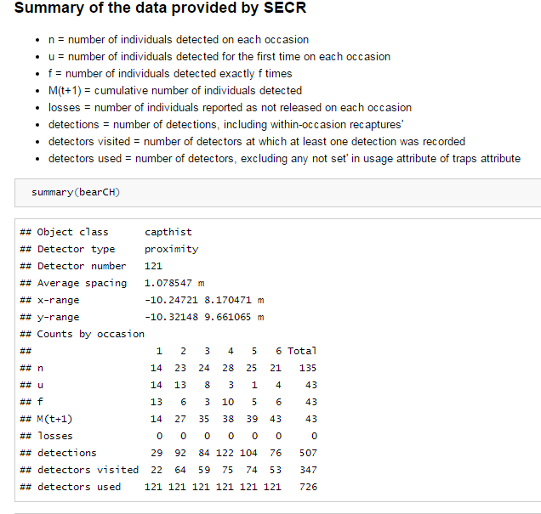

**Figure 2** Spider plot showing each trap location (dot), centroids for each individual that was captured (S), with lines connecting each centroid to all traps that detected the individual.

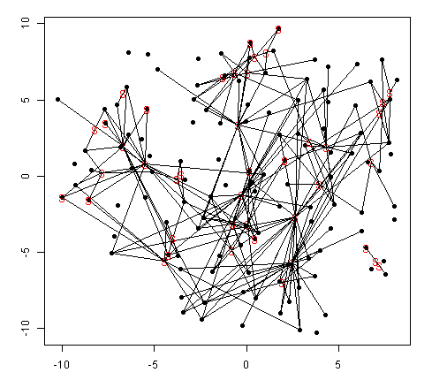

**Figure 3:** Estimated detection probability for Females (F) and Males (M) as a function of the distance between activity center and trap location for each of the 6 sampling periods using model go~t+Sex, σ~Sex (the model ranked #2 by AICc).

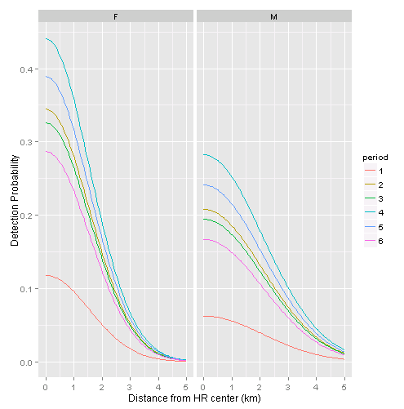

**Literature Cited**

Efford, M. G. (2015). secr: Spatially explicit capture-recapture models. R package version 2.9.5.

<http://CRAN.R-project.org/package=secr>

Laake, J.L. (2013). RMark: An R Interface for Analysis of Capture-Recapture Data with MARK. AFSC Processed Rep 2013-01, 25p. Alaska Fish. Sci. Cent., NOAA, Natl. Mar. Fish. Serv., 7600 Sand Point Way NE, Seattle WA 98115.

R Core Team (2014). R: A language and environment for statistical computing. R Foundation for Statistical Computing, Vienna, Austria. URL http://www.R-project.org/.